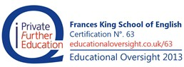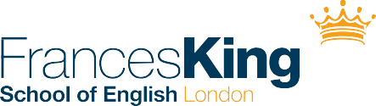

**SPECIAL OFFER FOR TURKEY 2016 & 2017**

Special **London** offer

10% discount on tuition fees, for all bookings (12+ weeks) received from now until the end of May 2017

– for programmes starting from September 2016

Terms and Conditions

* + - Offer limited to: ***Standard (am/pm), Intensive & Intensive Plus Programmes*** in London - 12+ weeks
    - Offer does not include One-to-One, Family, Teenager or any Dublin programmes
    - Terms and Conditions as per our brochure and Terms and Conditions 2016 / 2017

***This offer cannot be used in conjunction with any other offers***